Name: ______________________________ Date: __________ Parent signature: _____________
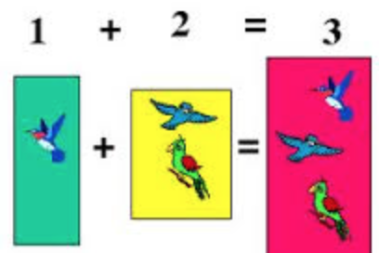
Math Assessment in Kid Pix Grade 3 Teachers & Mrs. Robinson

 |  | Excellent | Very Good | Good | Developing
Kid Pix Management | I created a Kid Pix project and saved it in my Student Class Folder. I also have a prewriting, rough draft and final draft stapled together. | 4 | 3 | 2 | 1
Math Sentence | I wrote sentences describing my math sentence. | 4 | 3 | 2 | 1
Picture in Kid Pix | I drew a picture in Kid Pix that showed my math sentence. | 4 | 3 | 2 | 1
Editing | I corrected my final draft of my Kid Pix project from the rough draft the teachers edited. | 4 | 3 | 2 | 1
Student | Shade in the face for each section for the score that you feel you have earned. | Total Points: | Comments:
Teacher | Circle the number in each section for the score that the student earned. | Total Points: | Comments

