Student Name ____________ Homeroom______ Animal Name________

Categorizing Your Fact Sheet

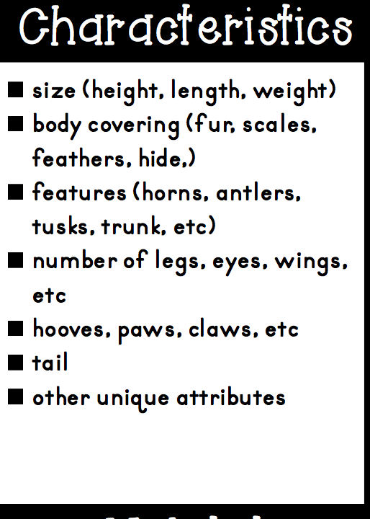
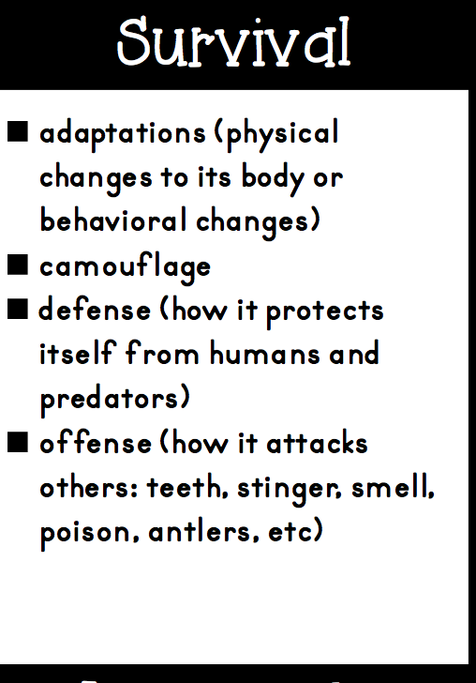
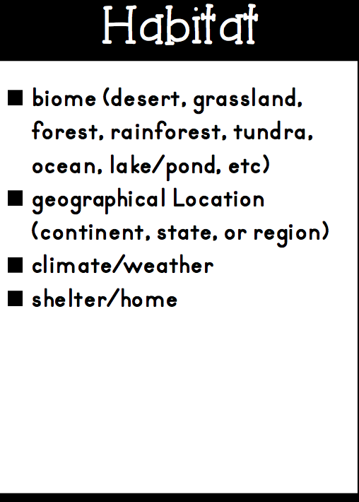
Now you are going to number your facts on your fact sheet. When you have completed this task put the number fact into a category box below that best describes that fact.
Conclusion – Write a concluding paragraph that summarizes the information you have gathered.
Hook - Introduction

