Name: ______________________________ Date: ______________ Homeroom_____

Excel Bingo Card Assessment
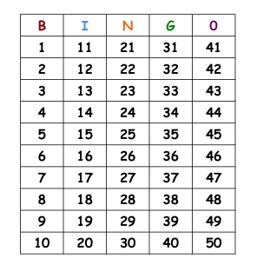
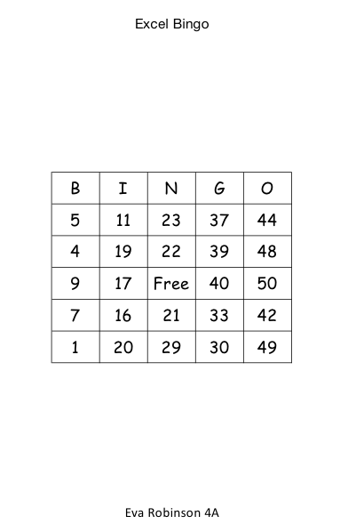
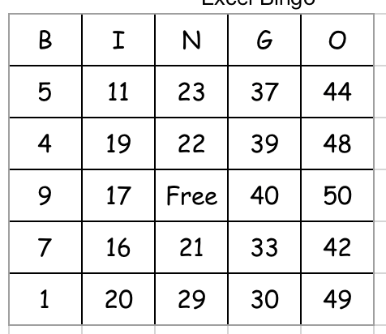
Header: Excel Bingo

Footer: Lorraine Kojima 4B
 |  | Student | Teacher
Header and Footer | I have typed the Header: Excel Bingo and the Footer: First name, last name and my homeroom. Proper capitalization has been used.
Borders and Alignment | All cells have a border and all letters and numbers are centered in each cell.
Bingo Card Alignment | Bingo card is aligned in the middle of document.
Numbers in Columns | All numbers in each column are appropriate for each letter.
Student | Two points for each task completed. | Total Points:
Teacher | Two points for each task completed. | Total Points:

